JavaScript Syntax
Syntax Rules :
Syntax are the rules how programs must be constructed:
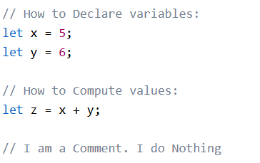
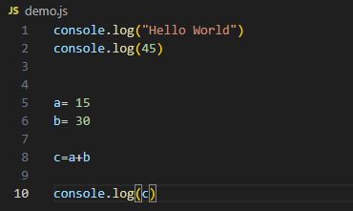
JavaScript Values:
The JavaScript syntax defines two types of values:
- Literals (Fixed values)
- Variables (Variable values)
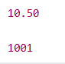

Strings are text, written within double or single quotes:
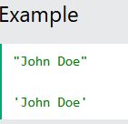
JavaScript Keywords
JavaScript keywords are used to defines actions to be performed.
The let and const keywords create variables:
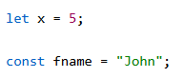

JavaScript Variables
Variables are containers for storing data values.
Variables must be identified with unique names.

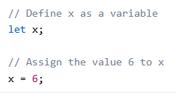

JavaScript Identifiers
An identifier is the name you give to a variable.
Rules for identifiers:
- Must start with a letter, _, or $
- Can contain digits after the first character
- Cannot be a reserved keyword (let, const, if, etc.)
- Are case-sensitive

JavaScript and Camel Case
Historically, programmers have used different ways of joining multiple words into one variable name:
Hyphens:
first-name, last-name, master-card, inter-city.
Hyphens are not allowed in JavaScript. They are reserved for subtractions.
Underscore:
first_name, last_name, master_card, inter_city.
Upper Camel Case (Pascal Case):
FirstName, LastName, MasterCard, InterCity.
Lower Camel Case:
firstName, lastName, masterCard, interCity.
JavaScript programmers tend to use lower camel case.

